ADDING FILES TO A BRANCH
There are two ways to add file(s) to a ‘Branch’
Local Repository
- Switch to branch where files need to be added using command
Git checkout branch-name
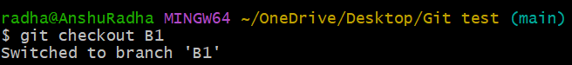
- Add a file to your local folder. For example, “File-2 “
- Add file to the branch using command
git add file-name
- Commit the file using command
git commit -m “short note about commit”
- push the file to remote using command
git push -u origin branch-name
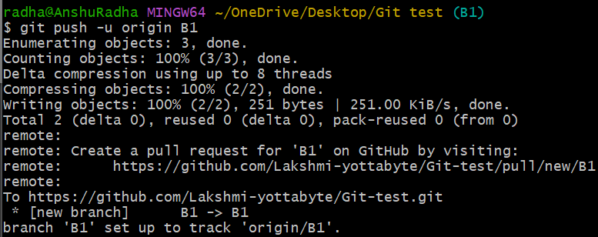

OUTPUT
File-2 added to branch ‘B1’ (see below screenshot)
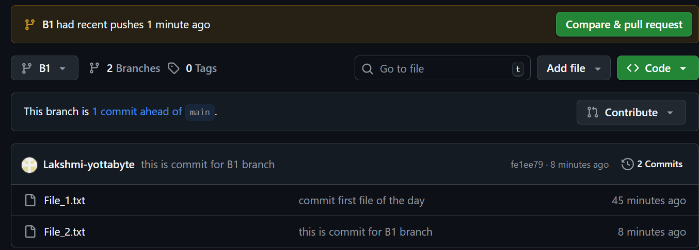

In Remote Repository
To add a file to a branch in repository, First select the branch

Select Branch
  - On GitHub, navigate to main  on top left side.
  - Select ‘View all branches’ from dropdown menu.
  - Under , select the branch

Add file
  - Click on , which appears on the top left of the page.
  - Click on the drop-downlist, two option appears:
      - Create new file
      - Upload files

- Create new file
- To create a ‘new file’, select ‘Create new file’ and add the details.
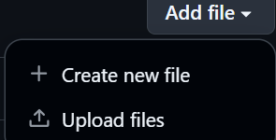
- Click on ‘commit changes’  to save the changes.
After clicking, the following window appears
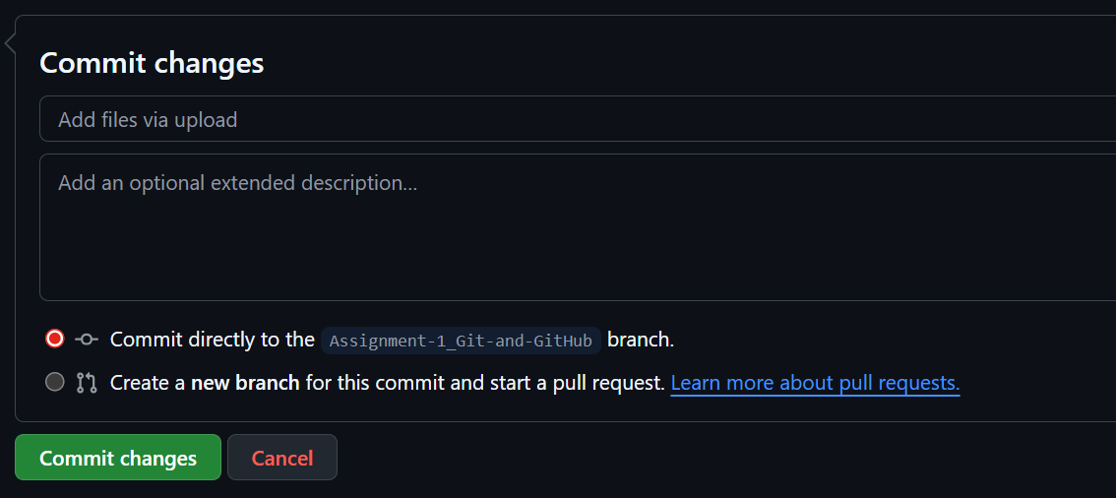
- In the first text box – briefly add what changes were made

- In the second text box, add brief explanation of the changes made for clarity and help with future reference.

- Now choose where the changes should be applied – on the main or to a branch.

- Finally, click on ‘commit changes’ to complete the process.

- Upload files
- To upload files, select ‘Upload files’ from drop-down list
The following window appears

- Either drag and drop the files to add them to the repository or click on ‘choose your files’
- Now, commit changes as described above to complete the process.
